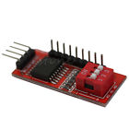**PCF8574T I/O for I2C Port Interface Support Arduino Cascading Extended Module**

**Description:**

* Module function:
* This is the I/O extended module, which use for I2C interface, you can use two of the module to extend 8 I/O. Support cascading, and you can use at most 8 modules to extend 64 I/O at the same time. Can be changed the address by set toggle switch
* PCB Size: 36 x 16mm/1.41*0.62"
* Every 2 seconds, make P0-P7 port output High level, Low level, and put 3 toggle switches to ON, the address of module is 0x27
* Quantity:1pc